User Manual for Days

1. After installing the app onto an iPhone, tap on the app icon to launch it.

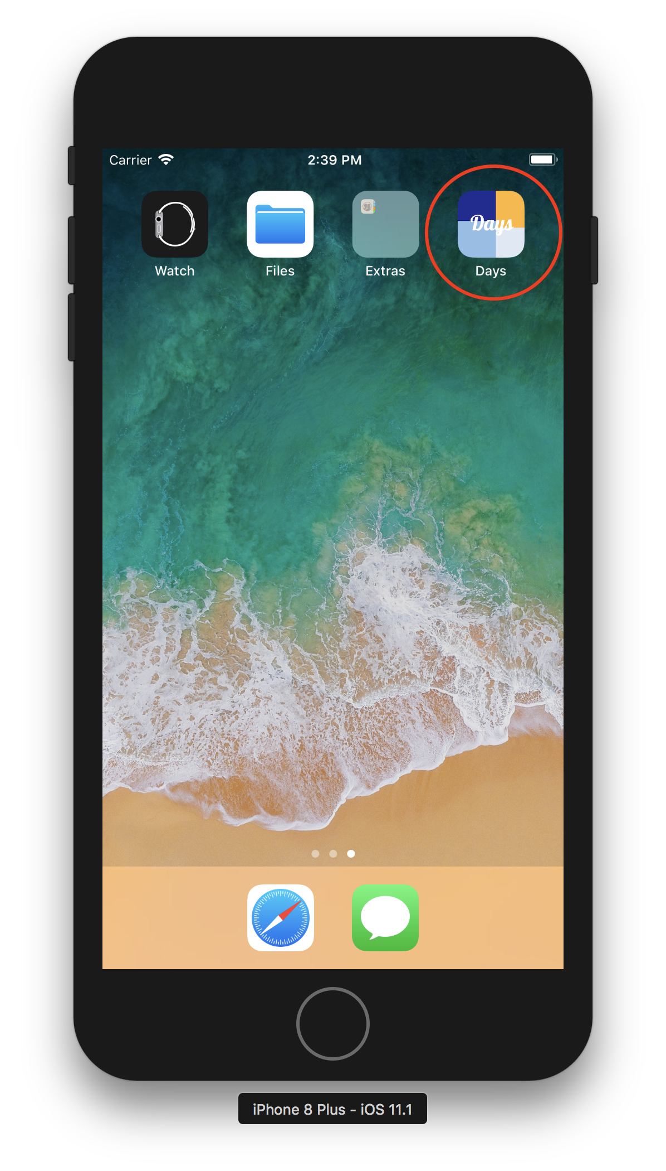

1. At the first time the app is launched, the users will be asked if the notification is allowed for this app. It is recommended that the users allow the notifications so that they can use the reminder function of the todo tasks later.

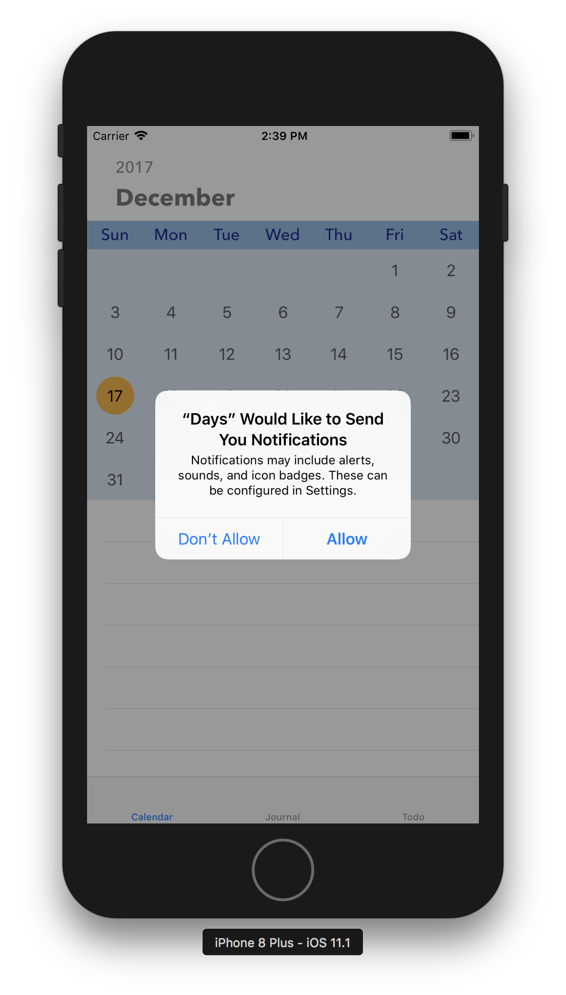

1. The calendar view will be the first view of the app.

The top half of the screen is the calendar. The selected date is in black color with an orange circle around, and the rest of the date numbers is in grey. If there’s any event (journal or todo) on a particular day, there will be a little black event dot under the number of that date.

The bottom half of the screen is a table list of all the journals and todos of the selected day. The users can tap on the table cell to view the whole content or revise the content.

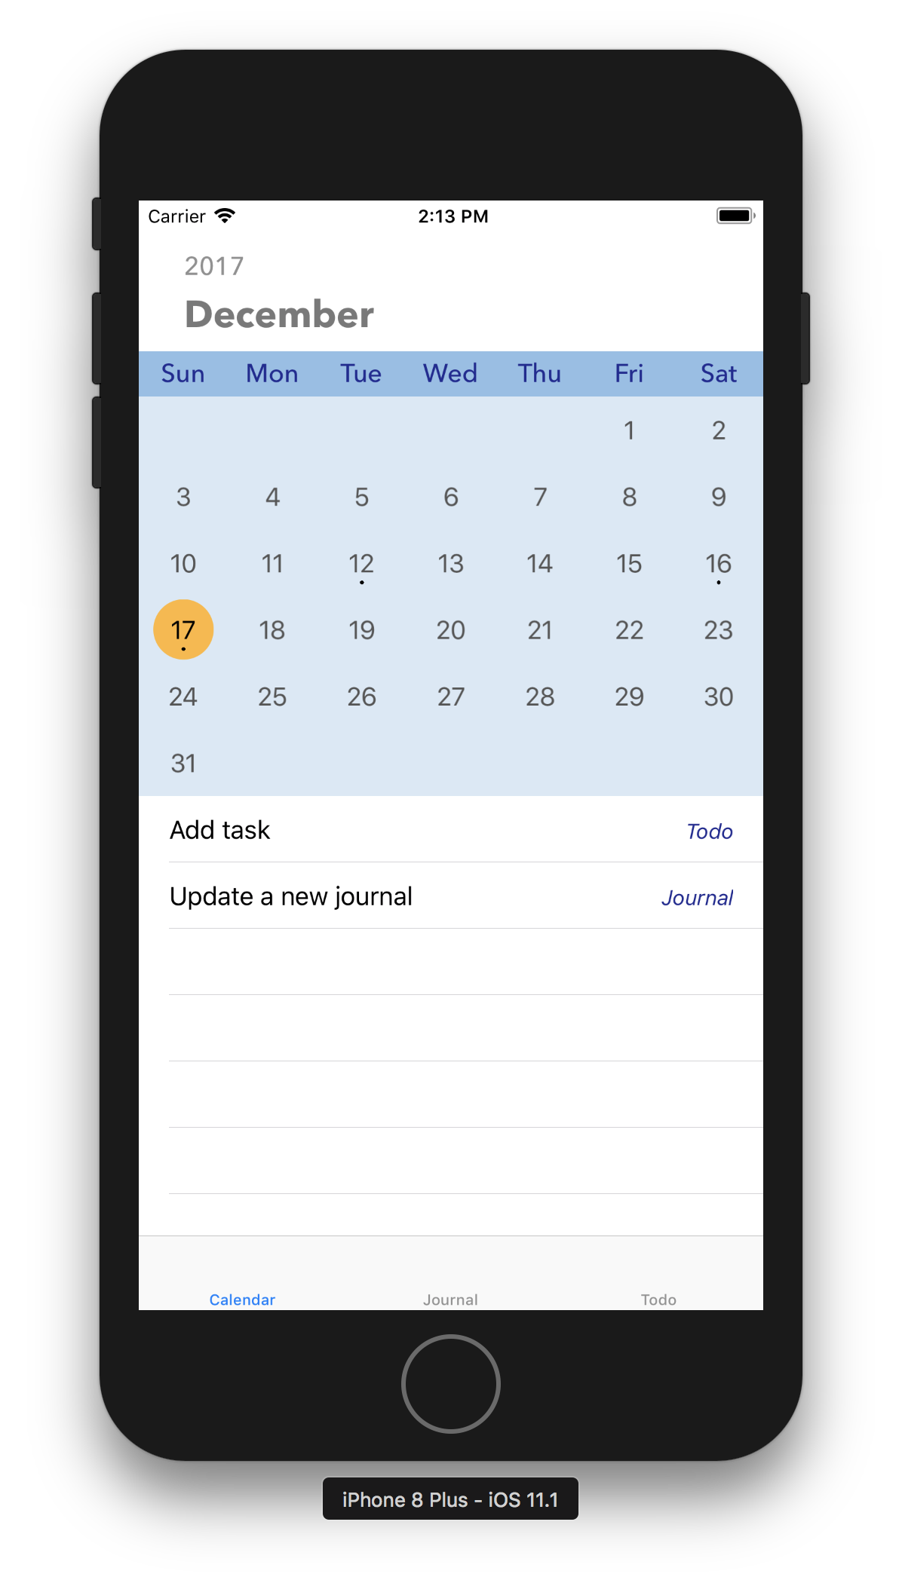

1. Tap the Journal tab on the bottom bar to go to the journal view. The journal view consists of the table list of the past journal and an add button on the top right corner. The content of the journal is shown as the title of the corresponding table cell, with the time and date on which this journal was created being listed below. Tap the add button on the top right corner to create a new entry of journal.

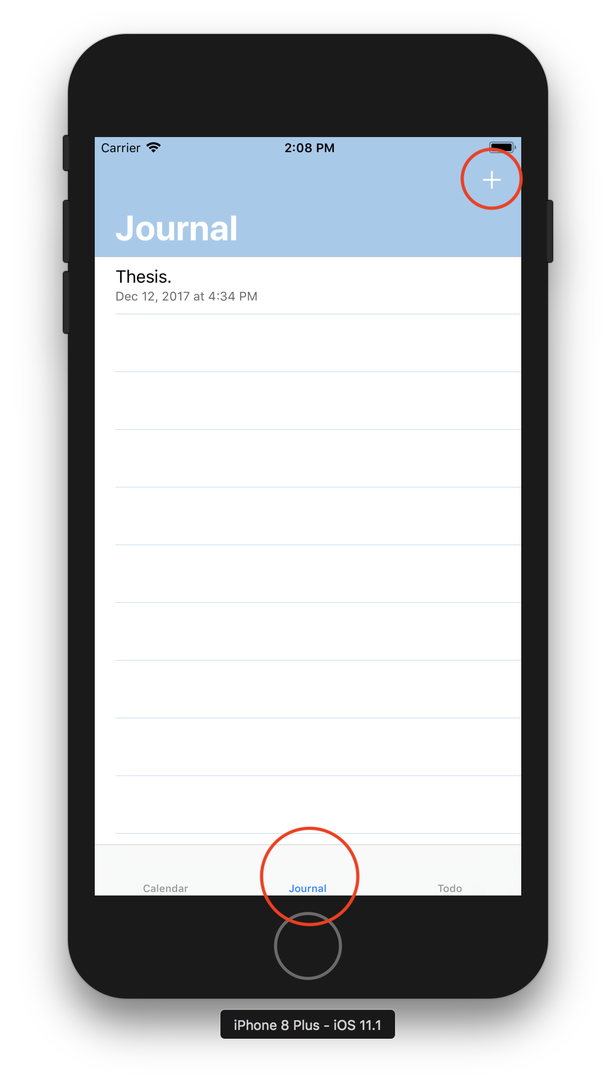

1. In the New Entry view, enter anything that you want to write for the journal. Tap the add button on the top right corner to save and add what you have written as a new journal. Or tap the arrow on the top left corner to go back to the journal view without saving the current entry.

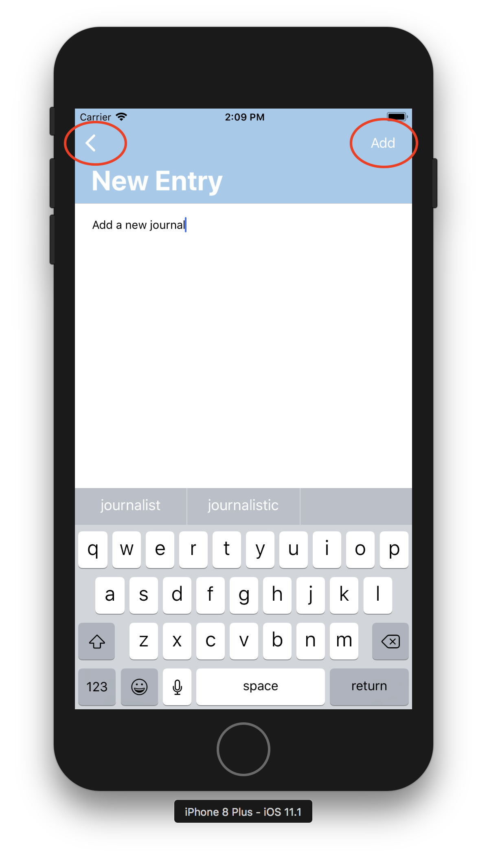

1. In the journal view, tap a table cell to view the entire content of that journal, or to update/revise it.

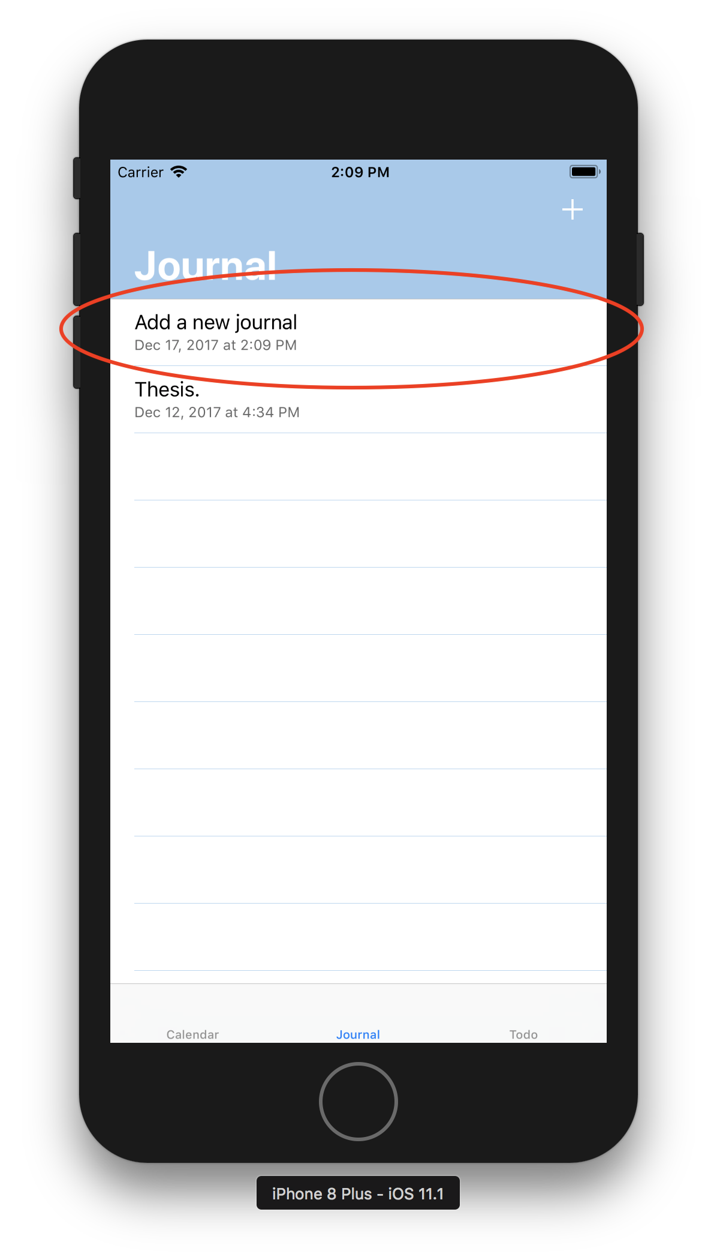

1. To revise the journal, tap on the text and change the content as you want. Tap the save button on the top right corner to save your change. Or tap the arrow on the top left corner to go back to the journal view without saving the current change.

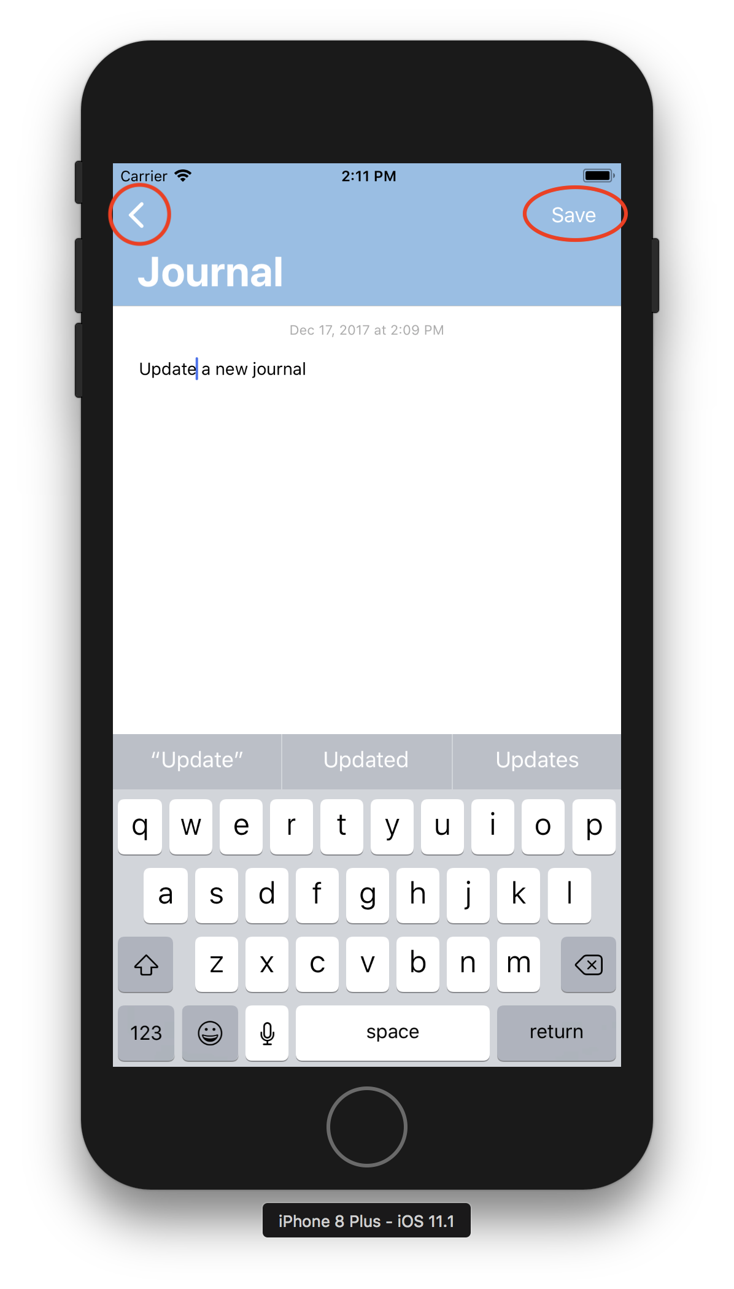

1. In the journal view, you can swipe a table cell left to show the delete button. Tap the delete button if you want to delete a journal entry.

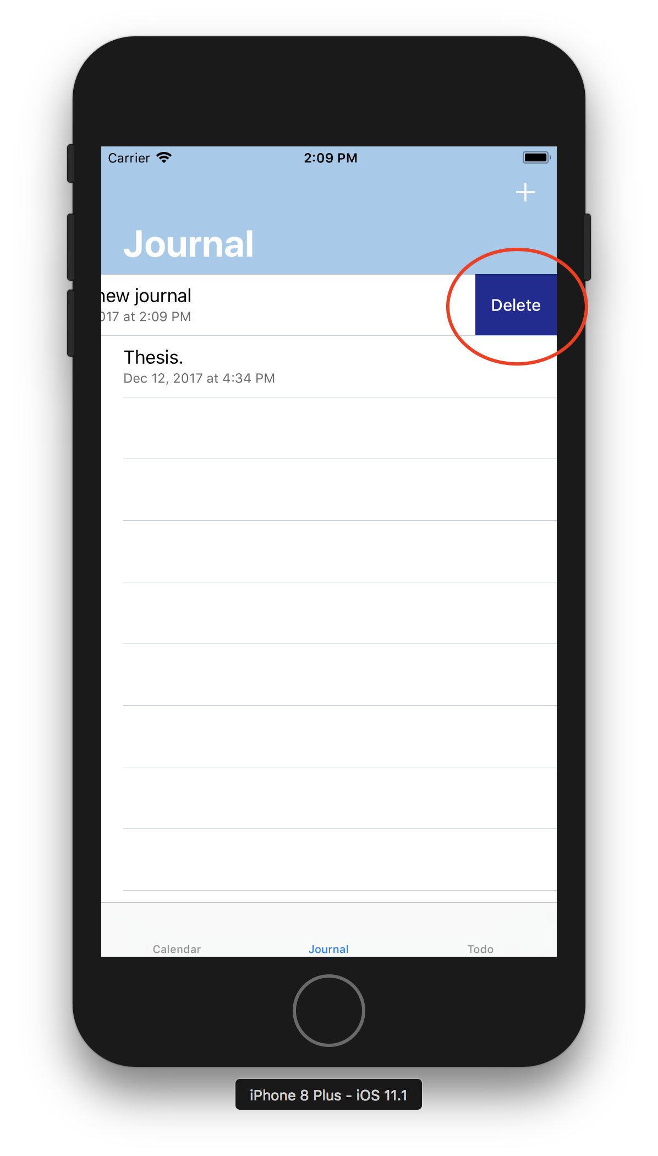

1. Tap the Todo tab on the bottom bar to go to the todo view. The todo view consists of the table list of the unchecked todos and an add button on the top right corner. The content of the todo task is shown as the title of the corresponding table cell, with its due date and time being listed below. The due date will be in red color if the due date is passed and the item is not checked. Tap the add button on the top right corner to create a new todo.

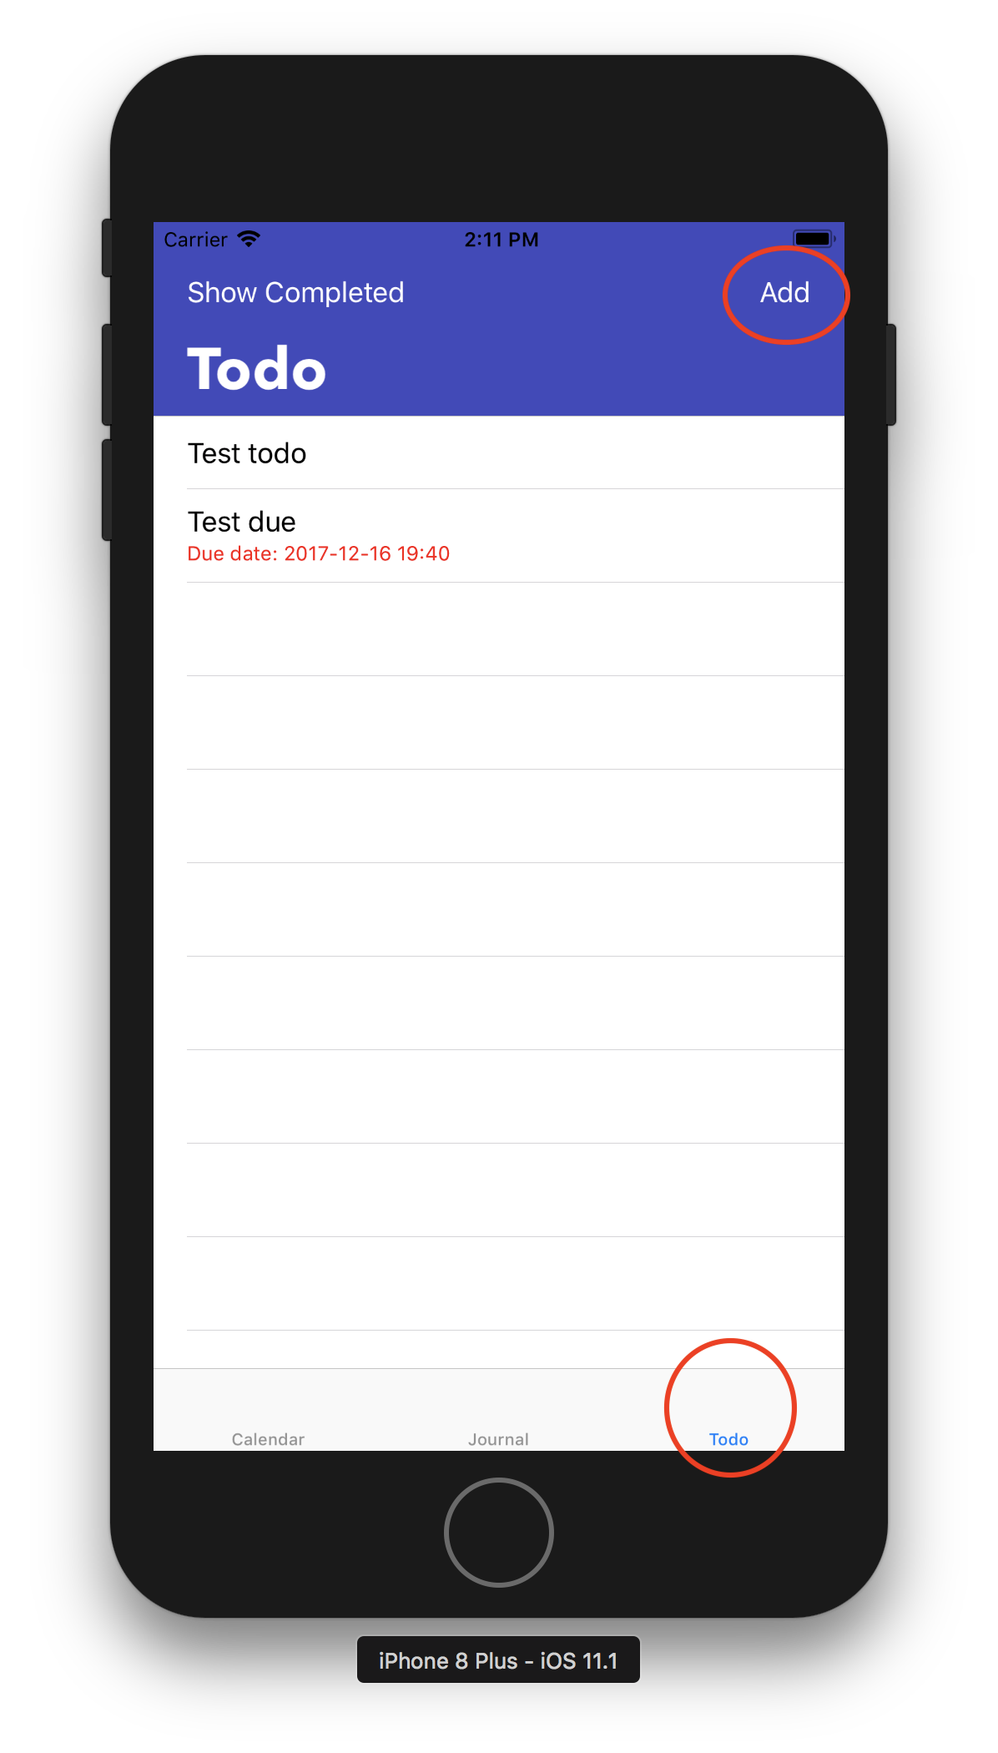

1. To add or revise a todo item, enter the task content in the text field on the top half of the screen.

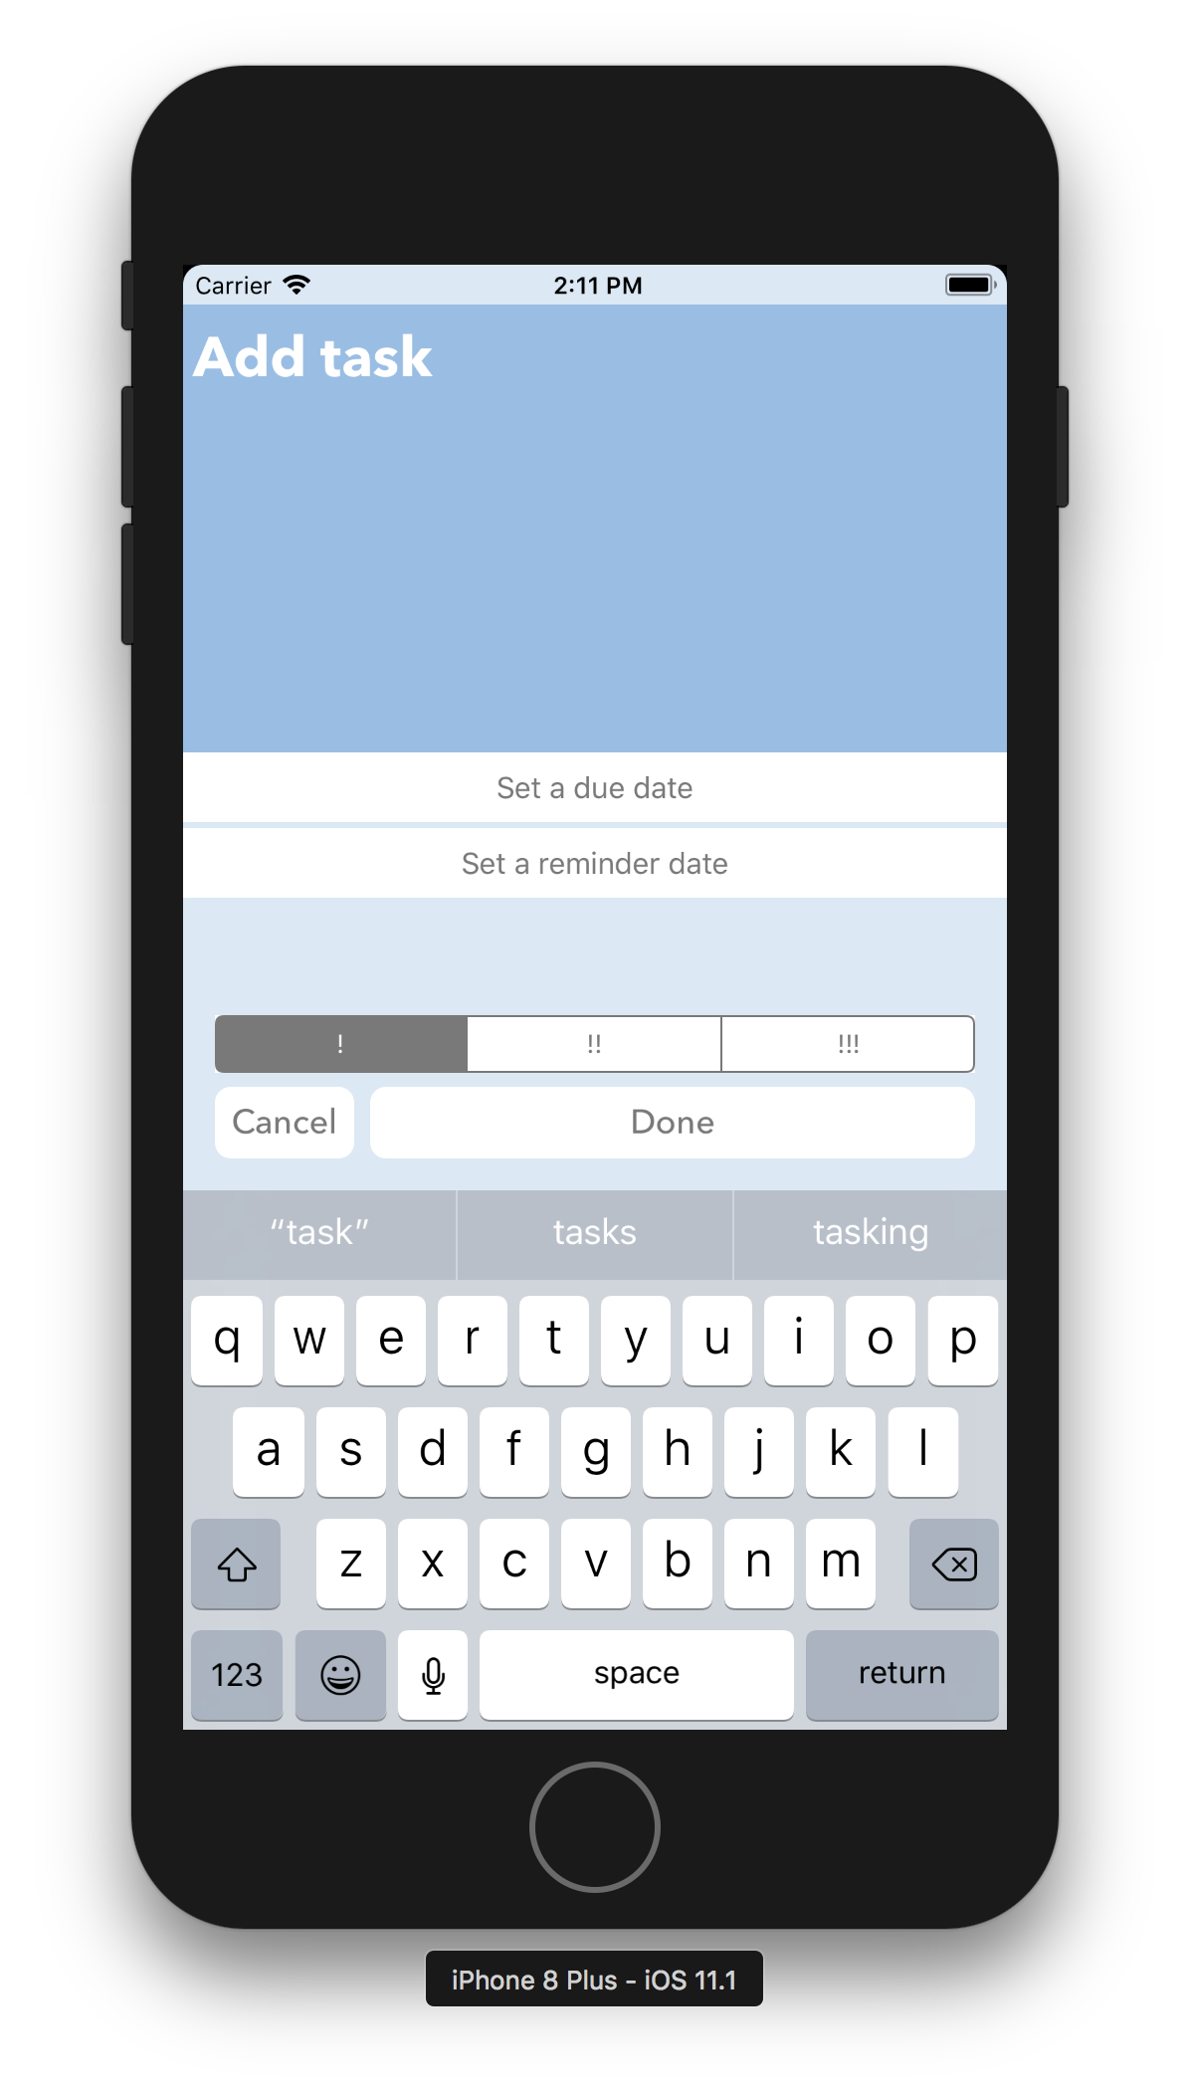

1. Tap on the “Set a due date” and “Set a reminder date” button to set the due date and reminder date respectively.

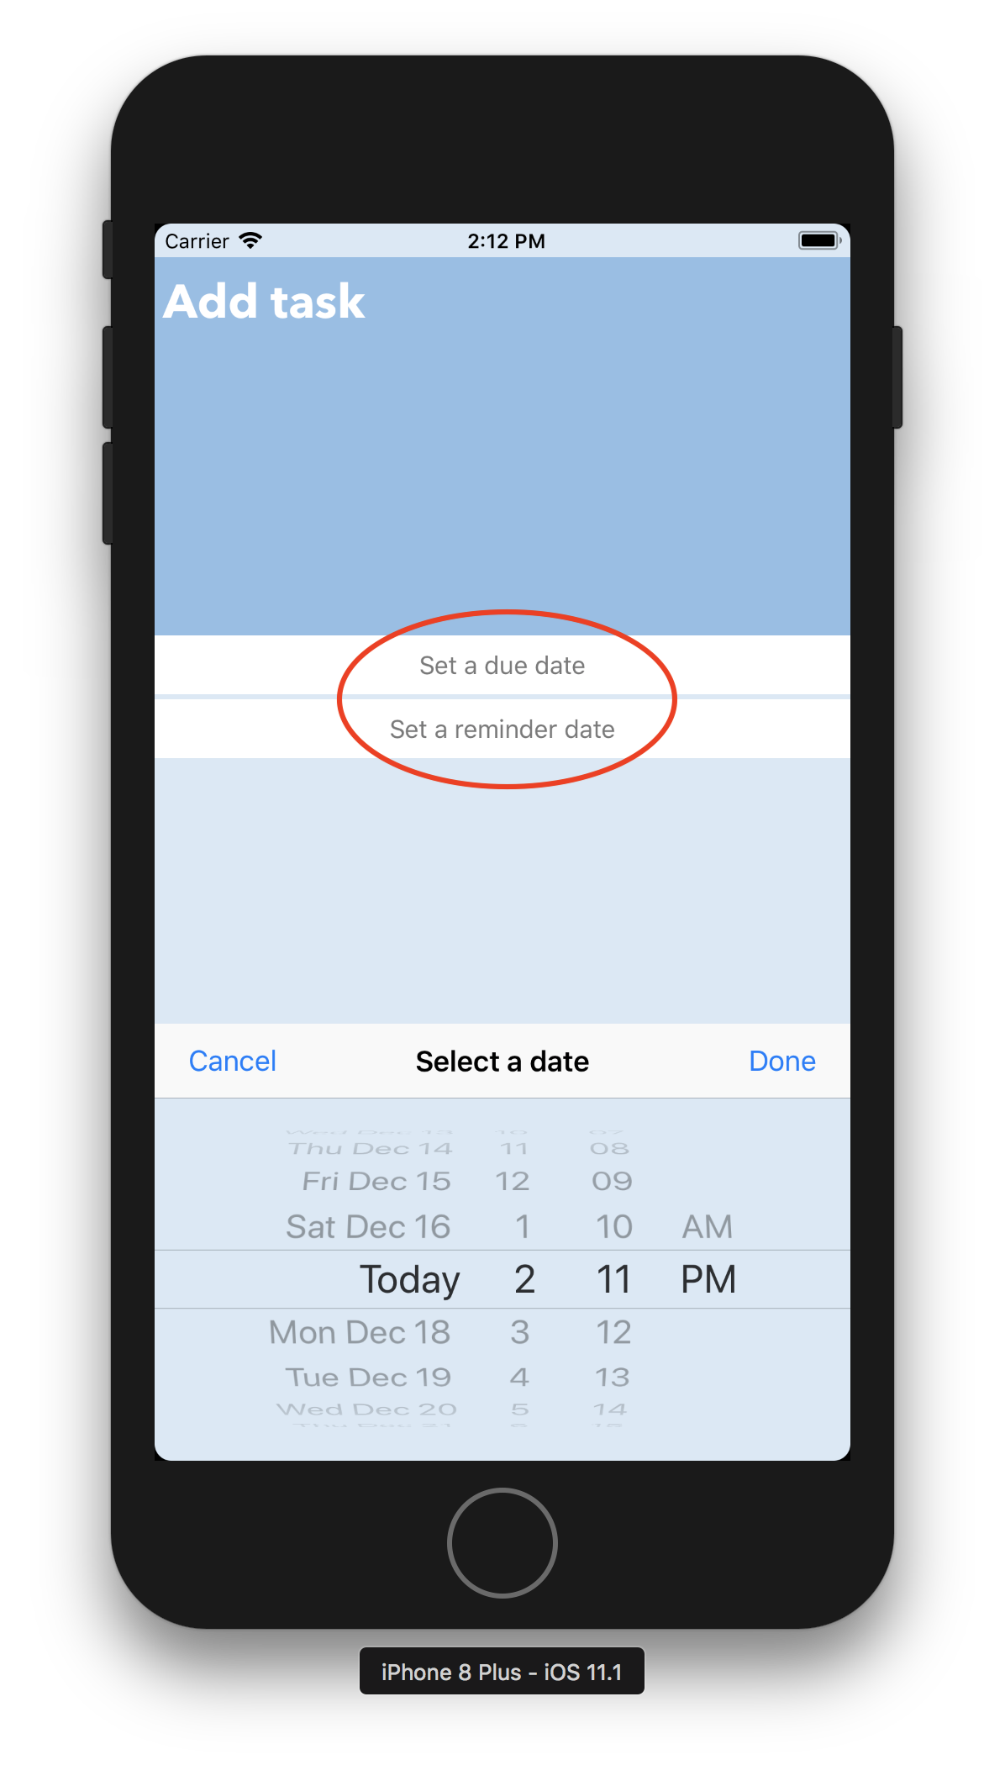

1. The user can choose the importance level of the task by tapping one of the three buttons above the done button. The button with one exclamation mark indicates low-level importance. The one with two exclamation marks is the medium level and the one with three exclamation marks indicates high importance level.

Tap the done button to add a new todo or save the revision.

Tap the cancel button to go back to the todo view without saving the changes.

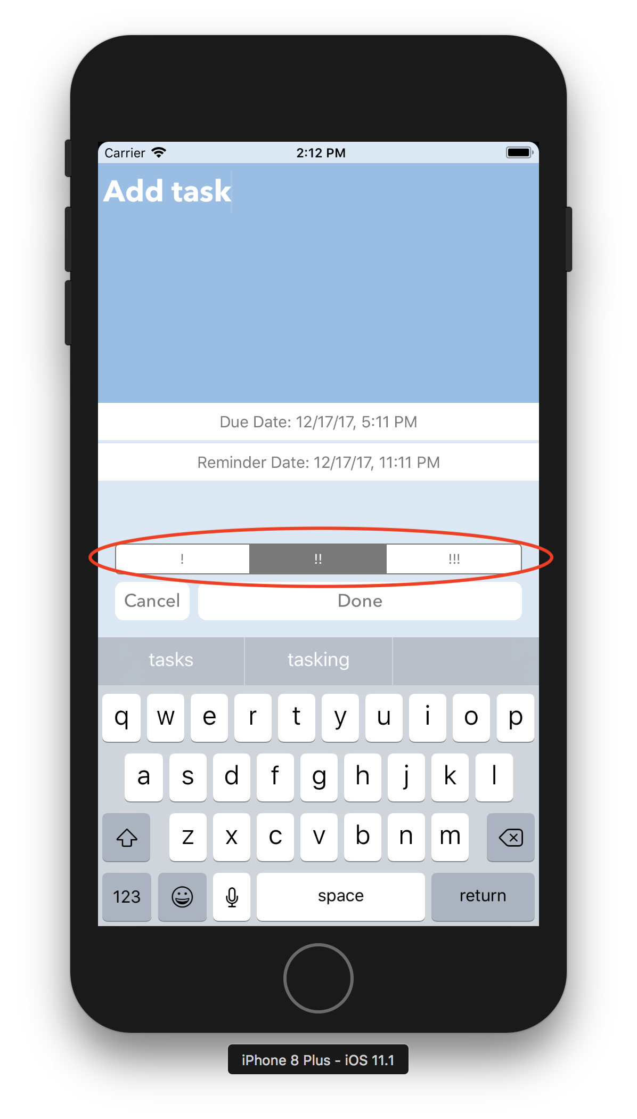

1. The due date will be shown in the todo view. If the todo task has a reminder date being set, there is a bell icon on the right side of that cell.

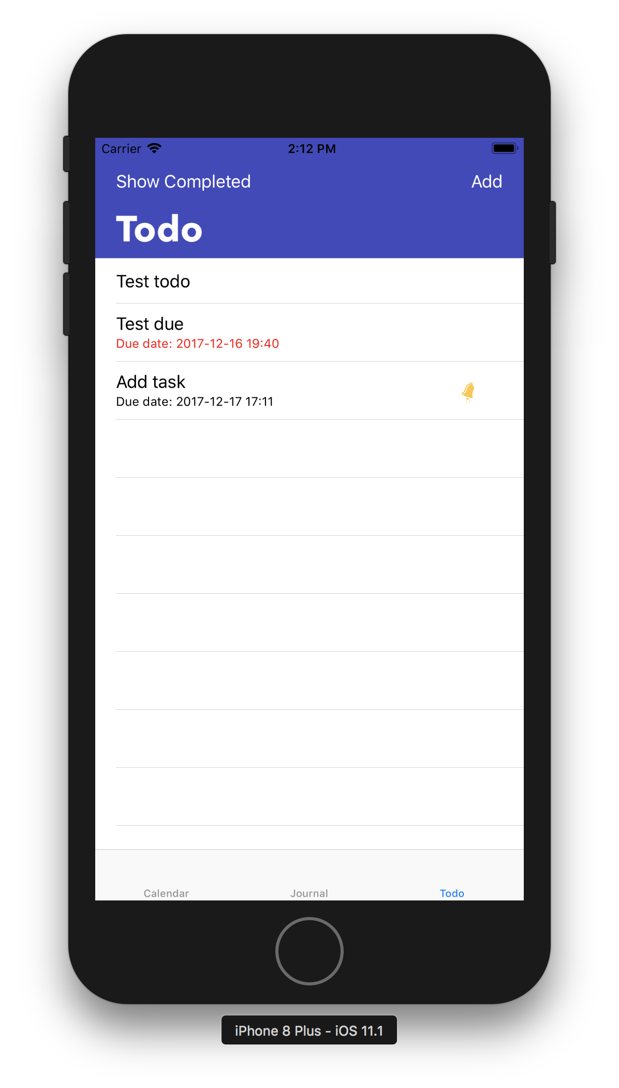

1. Swipe a cell left to show the delete button and swipe right to show the check button. Delete a todo task will remove it from the list forever. Check a todo task will remove it from the list temporarily but the users can still access it by clicking the “show completed” button

